**The leadership role of the project manager in an**

**international project**

**June 14, 2019**

**Prepared by Ahmad Oudat**

**ABSTRACT**

The primarily purpose of this thesis was to study the role of the project manager in an in international project. The research studies the leadership skills and competencies of the project manager. Also, the differences and challenges between national and international projects studied.

The necessary data for the theoretical part are collected from academic books, scientific articles and precious researches. Purpose of the theoretical part is to gain a deep understanding of the topic and the theories and models around it. The fifteen-leadership competency model was selected for the base of the empirical part.

For the empirical part, Interviews were used as a qualitative research method. The four interviewees were highly experienced in project management in international projects and the interviews were carried out with open questions.

The conclusions have been drawn from the analysis and comparison of the theoretical part and the empirical part. The analysis revealed what were the important competencies for a successful project manager, according to the literature sources and the opinion of the interviewees. As a final result, six important competencies emerged from which a competency profile for a successful project manager was assembled.

Key words: Project management, Leadership, International project management, Leadership

**TABLE OF CONTENTS**

1 INTRODUCTION 1

1.1 Subject and objective 1

1.2 Research question 2

1.3 Research methods 2

1.4 The structure of the thesis 4

2 LITERATURE REVIEW 6

3 DEFINITIONS 10

3.1 Project 10

3.2 Project management 11

3.3 Project manager 11

3.4 Skills of the project manager 12

3.5 Leadership 13

3.6 Leadership skills 14

4 INTERNATIONAL PERSPECTIVE 17

4.1 International project 17

4.2 Multicultural team 17

4.3 Leadership in different cultures 18

4.4 Project management in a multicultural environment 19

5 THEORETICAL PART 22

5.1 Fifteen leadership competencies 22

5.1.1 Managerial leadership 23

5.1.2 Intellectual leadership 26

5.1.3 Emotional leadership 27

6 EMPIRICAL PART 31

6.1 Interview nr. 1:Rana Dababneh 31

6.1.1 Challenges in international projects 32

6.1.2 The importance of the project manager for the success of the project 32

6.1.3 Analysis of the competency figure 33

6.1.4 Important competencies 34

6.2 Interview nro. 2: Omar Shoshan 35

6.2.1 Challenges in international projects 36

6.2.2 The importance of the project manager for the success of the project 36

6.2.3 Analysis of the competency figure 36

7 CONCLUSIONS 45

7.1 The clusters 45

7.2 The competencies 47

7.2.1 Motivation 48

7.2.2 Engaging communication 49

7.2.3 Interpersonal skills 49

7.3 The international perspective 50

7.4 The competency profile of a competent project manager 50

8 RECOMMENDATIONS 52

9 APPENDIXES 54

9.1 The Interview form 54

10 LIST OF FIGURES 55

11 LIST OF REFERENCES 56

# INTRODUCTION

This chapter is an introduction to this thesis. The reader will get acquainted with the subject and the objective of this thesis. The readers will get the general picture of the perspective of the research. Also, the research questions and methods are defined and explained. In the end, the structure of this thesis is also explained.

## Subject and objective

The subject of this theses is the leadership and the role of a project manager. The subject is viewed in a national and in an international perspective. The thesis to focuses on the leadership role of the project manager/leader. The goal is to understand what kind of competences are needed from an effective and successful project manager in an international project. The study will in the end through theoretical and empirical research identify and build a competency profile for a good and effective project manager through literary sources and interviews. One will see what kind of competencies and capabilities a project manager needs nowadays in a more and more challenging environment.

The traditional management style has focused more on managing things, but the environment has changed more in to managing people. It is important to move from issue management to a management style that leads and coaches people more than just controls.

Key things in a project are managing resources, achieving goals and keeping schedules, but it becomes more and more important to focus on human resources and being able to manage people. One could say that people have become one of the most important resource in business. That is why leadership skills are becoming one of the most important skills of the project manager to have.

This thesis will unfold basic definitions concerning projects and project management. Also, it will have a look to the skill set of a project manager and then especially focusing on the leadership skills and competencies. Furthermore, the thesis will introduce theories and background information about the different leadership skills and competences, and their implementation. After having interviewed professionals in the field of project management and doing a comparison of the literature knowledge and the interviews, there will be a profile of a competent project leader assembled.

More and more companies operate in international markets and multicultural projects are everyday life in many companies. That is why the subject is viewed not only in a national perspective, but also in an international perspective. Working in an international environment, one must take into consideration different challenges, compared to national projects. Dealing with cultural differences, affects the leadership style and leadership skills needed, and thus the whole success rate of the project.

## Research question

The main research question in this thesis is: “What leadership skills and competencies are the most important ones for a successful project manager?”. There is no right or wrong answer to this question, but the idea is to find out what kind of elements does a project managers knowledge profile contain. In the definitions chapter will evolve around questions like “What is a project?” and “What is project management?”. These are basic questions which are important to answer before the main research part, so that the reader will get a basic knowledge of the thesis subject in general. The international perspective will be taking in to account through questions like “How do national and international projects differ from each other?” and “What are the biggest challenges in leading international projects?”. The goal is that by answering these questions there will be a better understanding about what is working in an international environment and project.

## Research methods

The research question of this thesis is to be solved by qualitative type of research, which answers the questions what kind of, how and why. This research method is the best for this particular study to gain a deep understanding of the thesis subject.

There are two parts in the study: theoretical part and empirical part. The theoretical part in this thesis covers leadership-, project management- and organizational behavioral theories and leadership skill models in a national and international perspective. This part contains information collected from academic books, research papers and current studies. The purpose of the theoretical part is to provide important data and information for the reader to get better understanding of the empirical part. The theoretical and empirical parts will be compared together to get evident and potential differences and similarities between theoretic and praxis.

In addition to the literature sources there is the empirical part where the research contains interviews from people that have experience in project management in international and national projects, in public and private organizations. The reason why interviews have been chosen as a research method, is to gain deeper understanding about the subject and get practical information of the subject from the professionals in the field of project management.

The interviews were carried out by open questions, so the interviews were not too restrictive. First there were basic questions about challenges and differences in international and national projects. After that the theoretical part of the study was presented to the interviewees. They were asked to fill in an excel sheet on the importance of different leadership competences and to evaluate values of the competencies. In addition, general data was collected from the people being interviewed e.g. education, professional background and experience in project management. The interview form can be seen in the appendixes. The variety of the interviewees gives a wide and practical perspective of the subject and that way a better view of the knowledge profile of a qualified project manager.

## The structure of the thesis

In order to give the readers a clear structure the thesis is divided to eight main chapters. Also in the beginning of every big entity there is a short description of the chapter coming up. One can see the basic structure visualizers in the figure bellow.

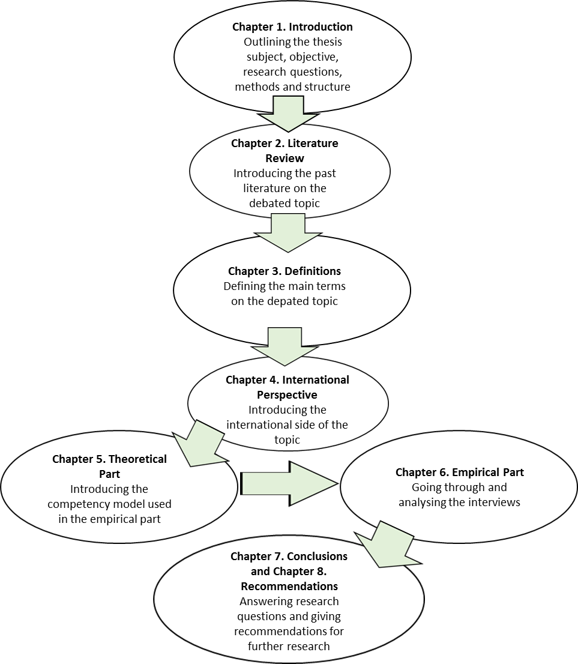

Figure 1. Thesis Structure

In the **introduction**, the basic information of the study is displayed, including the aim and the objective of the thesis, the research questions and the methods used to answer the research questions. **Literature review** displays and explores the literature and previous studies used as sources i.e. it gives an overview of the study content.

The **definitions** chapter introduces and describes the main terms associated with project management and leadership used in this thesis. This gives one the basics for understanding the research part. Also, the **international perspective** defines important terms associated with international project management. Purpose of this chapter is to bring the international perspective to inconsideration.

The **theoretical part** gives the substance of the leadership competency model used in the research of this thesis. The interviews are based on this competency model. The **empirical part** includes the dissolution and the analysis of the interviews. All four interviews are unwrapped one by one.

The **conclusions** chapter combines the theoretical and empirical parts together and it states the results of the study. Its purpose is to answer the defined research questions. The **recommendations** chapter opens up thoughts about the study and gives recommendations to future researches.

# LITERATURE REVIEW

This chapter provides information, studies and knowledge about the subject of the thesis, which have been obtained by researchers and authors in recent decades. In other words, this is an overview of the main academic sources used in this study and thus the bases of the thesis.

Project management and especially leadership in organizations and project management has become more important and more recognized in the last couple of decades. To get an updated view of leadership and project management today, one must use as current literature as possible. Most of the academic sources used in this thesis are from the 21st century. The idea that competency and especially the competency of the project manager would be success factors for projects is very new and it has been studied only from the 1990’s, so that is why the older literature is not relevant for this study.

Many sources recognize the project manager as the sole provider of leadership and he or she is the director that has knowledge and tools for different situations and contexts. Leadership has been started to be mentioned as a success factor in the late 80’s, but it is presented rarely in the history of success factors. Nowadays it is seen more clearly that leadership has an influence on the project success. For example, the study of Müller and Turner (2007) and Geoghegan and Dulewicz (2008) strongly imply that there is a relationship between project success and leadership.

Although many authors have an opinion that leadership style and competencies have a significant impact to the success of a project, it rarely shows in researches. For example, quite a famous list of success factors for projects by Jeffery Pinto and Dennis Slevin (1988), does not mention the project manager. This kind of researches believe that project success is defined by techniques and tools. (Müller and Turner 2010, 1) In the study of Khan, Long and Iqbal (2014) was brought up in the abstract that although there is a lot of literature about project success, the importance leadership competencies is still a major topic to investigate. Leadership has been a topic in organizational success and now it is also coming more important in the researches in project management, although it has been neglected before.

One reason for that could be that when interviewing project managers about the success factor of a project, they ignore their management skills as a success factors. (Müller and Turner 2010, 1) Although it is known that good leadership skills and project success is linked, it is often forgotten or downgraded in literature about project management. Literature on project management often deals with technical elements e.g. time management, project structure etc. That just could be because of the modesty of the project leaders. Many times, project managers emphasize the importance of the team then the manager.

In their study, Khan et. al. concluded that the leadership competencies have positive impact on the project success and that they are very similar to the leadership competencies in organizational management. It is also noteworthy that the theories of leadership competencies in project management are still evolving. (Khan, Long and Iqbal 2014, 1)

Also, Yang’s, Huang’s and Wu’s study (2011) shows the relationship between leadership, teamwork, project success and project type. They suggested in their study that leadership can enhance relationships between team members and the teamwork influences the project performance. So, it can be said that because improved team work can be beneficial for the project performance and team work is can be improved by good leadership style, that leadership ultimately influences the project performance and through that the overall success of the project. (Yang, Huang and Wu 2011)

Emotional intelligence and competency theories are the latest theories touching. Emotional intelligence theories were born in the late 90’s and the competency theories in the 2000’s. The followers of the competency theories follow the fifteen leadership competencies, that have been absorbed from former theories. Many literature sources refer to the fifteen leadership competences suggested by Dulewicz and Higgs (2003). It is seen as a most comprehensive model. Some authors have used this model to support their own research. For example, Müller and Turner have implicated the fifteen leadership competencies to work for the project management in their book Projectoriented leadership. The same competencies have been suggested by other authors, but often the competencies have other names or they have been merged or split some of the competencies, but still are very supportive of the list suggested by Dulewicz and Higgs. Often the list of the competencies of the other authors are much shorter and less comprehensive. Geoghegan and Dulewicz (2008) simplified the original 15 competences in to two category groups and to 10 competencies that they felt where the most significant ones. This list shows the direct relationship with leadership and project success.

Goleman, Boyatzis and McKee suggested in their book “Primal Leadership: Learning to lead with emotional intelligence (2002), that leader’s emotional competencies are the biggest impact on the leadership effectiveness. They introduce four domains of emotional intelligences: self-awareness, self-management, social awareness and relationship management. Under those domains there are 18 competencies. One must remember that nobody can master all of these competencies. Not at least without major development. (Goleman et al. 2002)

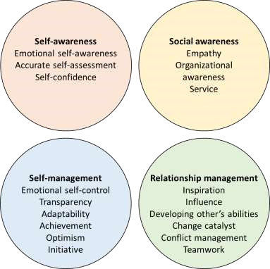

Figure 2. Emotional and Social Intelligence Competencies according to Goleman et. al.

According to Goleman et al. (2002) competencies of emotional intelligence in leadership deals with the question how leaders handle themselves and their relationships. It is leading with your heart and head together what makes great leadership and this is the reason why only with intellect you won’t be become a leader. (Goleman et al. 2002)

Also, the thesis is viewed not only from a national perspective, but also from the international perspective and that is why it is important to have up to date information about the challenges in international and multicultural environments. There are different opinions about the fact if the same theories and methods can be used in a national and in an international project. Based on background information and summarizing the sources, one could say that the most common opinion is, that the traditional management and project management methods used in national projects are a good base for the theories about the international projects. Taking in to consideration the complexity of the international projects, the old theories and methods need adjustment and updating, so that they correspond to the complexity of the multicultural environment.

# DEFINITIONS

In this chapter, the main terms and their definitions that are important for the thesis subject, are defined. The reader will also get background information that is central for understanding the main subject. There are multiple sources used, to get a comprehensive picture of the basics.

## Project

“A project is direct work that is aimed at achieving specific goals within a defined budget and schedule.” (Lientz and Rea 2003, 3) Project differs from normal work. The routine work in an organization, also called processes or operational management, is typically ongoing and repetitive. Whereas projects are unique and temporary and the objective of a project is usually something new that is different from normal work. (Köster 2010, 3) Because a project is something new, it carries a high level of risk and one cannot always be sure of the outcome of the project. A project also differs from normal work, that it has a defined beginning and an ending. (Bell 2013, 2)

Projects can differ from each other for instance by size. Meaning there can be small projects involving only two people and large cross-national mega-projects. Projects can also differ in the kind of organization initiating the project, the industry the project belongs to and the purpose and the scope of the project. Projects can be long or short term. As we can see there is a lot of different kind of projects, but regardless of the project type, each project has three main characteristics in common: projects are limited, unique and risky. (Köster 201, 3)

A project is intended to be temporary, although in reality the time line can be really long. As mentioned before, to be a temporary function each project should have a clear beginning and ending. In a long-time project, at least a well-defined part of a project should not exceed three years. A project should typically deliver beneficial changes, i.e. bring value to the company and this should justify the invested resources in the project. Also, the fact that projects are not repetitive is what makes them unique and since they do not comprise routine work, they involve certain amount of risk that must be managed. (Köster 2011, 3-4)

## Project management

“Project management is used as a higher-level term that covers all the planning, monitoring, coordinating and controls that are required when developing or redeveloping systems of processes, or in problem-solving. – In contrast to project management, line management relates more to the ongoing business and to the management of the relevant organizations.” (Kuster, Huber, Lippmann et.al. 2011, 9) Project management takes a staged approach to reduce complexity and ensure efficiency. It manages projects so that they create value for organizations. Typically, the project life cycle consists of four main phases: initiating, planning, executing/controlling and completion. (Köster 2011, 5-6)

## Project manager

The project manager is responsible for the execution and operational running of the project. One could say they are kind of process designers. (Kuster, Huber, Lippmann et.al. 2011, 106) The project manager provides leadership in planning, organizing and controlling the work. Gido and Clements have brilliantly capsulised the position of the project manager: “If the project team would be an athletic team, the project manager would be the coach”. He or she coordinates the activities of the team members and makes sure that that they perform right tasks in proper time. (Gido and Clements 1999, 84)

The project manager is responsible for managing resources (time, money, people, facilities, equipment, materials, information, technology), relationships (stakeholders, team, suppliers), requirements and expectations and also risks. (Bell 2013, 9) Some of these tasks can be delegated and executed by members of the project team, but the project manager is ultimately responsible that they are done. As we can see the project manager has a lot of things to handle and there for it can be a challenging but rewarding position. In a nutshell project manager is a key factor for a successful project. (Gido and Clements 1999, 84-85)

## Skills of the project manager

According to Project Management Handbook written by Kuster, Huber, Lippmann etc. (2011,108) the project manager should be able to offer subject knowledge, familiarity with different methods and leadership skills.

By **subject knowledge** is meant specialist expertise that are needed in specific projects for example in standard or recurring projects. The project manager does not have to be the expert in specific subject. Normally he or she is the leaders/managers of the experts. (Kuster, Huber, Lippmann et.al. 2011, 108)

The knowledge of **different methods** in structuring, planning, problem solving etc. are normally expected of the project manager. (Kuster, Huber, Lippmann et.al. 2011, 108) Knowledge of these should help the operative running of the project. In general, awareness of these methods are often learned on the job or through further training, but also nowadays for example many universities do offer education of these different methods of project management. (Kuster, Huber, Lippmann et.al. 2011, 108)

Above all, project manager must be able to lead people and there for to have good **leadership skills.** In this context, project management goes more in the way of leadership then to managing. This is very challenging and calls for high level of empathy and social competence. (Kuster, Huber, Lippmann et.al. 2011, 108) “In general, the lower importance of subject knowledge, the higher the need for leadership skills, and vice versa.” This is also a thing that depends on the type of the project. The project managers do not have administrative authority over the project team, so he or she must lead the team without formal authority and there for use leadership skills motivate the team to work in the project. (Kuster, Huber, Lippmann et.al. 2011, 109)

This thesis concentrates to the leadership role of the project manager and that is why leadership and leadership skills are viewed in the next chapter more closely.

## Leadership

Lussier and Achual (2013, 5) have written, that “there is no universal definition of leadership, because leadership is complex and because leadership is studied in different ways that require different definitions.” But their own definition of leadership is that it is “the influencing process between leaders and followers to achieve organizational objectives through change”. They have five key elements to their definition: leaders followers, influence, organizational objective, change and people. (Lussier and Achua 2013, 5) Leadership has also been defined by Gido and Clements (1999, 85) as “getting things done through others”. In project management, this means that the project manager achieves results through the project team. In other words, inspiring people assigned to the project to work as a team to achieve the project objective.

The leadership term can be used for the leadership of an organization or a company and for the leadership of employees and running a project requires both. (Kuster, Huber, Lippmann et.al. 2011, 213) When using the leadership term in the sense of management it means securing the company’s livelihood under the changing environment. In other words, it means creating the strategies, goals and policies of the company. Employee leadership means intentionally influencing and motivating team members with a view to achieving goals. The task of employee leadership also involves issuing, asking for and correcting goal-oriented arrangements. (Kuster, Huber, Lippmann et.al. 2011, 214-215)

There has always been a question if leaders are born or made. We get certain traits, behaviors, attitudes and emotional responses when we are born and some our characteristics we get from our upbringing, society and culture. But, through education and training we can change our personal profile to match better to the context within we are working. So, we can modify our profile that we are born with to a certain degree. (Müller and Turner 2010, 8)

“Effective project managers have strong leadership ability, the ability to develop people, excellent communication skills, good interpersonal skills, the ability to handle stress, problem-solving skills and time management skills.” (Gido and Clements 1999, 85) Like discussed earlier these are skills and competences that one can develop through training and so on improve one’s leadership abilities.

## Leadership skills

The skills of the leader can be distinguished to hard skills and soft skills. By hard skills

(also described as subject knowledge in the Project manager handbook written by Kuster, Huber, Lippmann et.al.) meaning technical or industry-specific knowledge and the ability to communicate this knowledge with the team and by soft skills meaning team building empathy or conflict management skills. In an international project the cross-cultural competence may be the most relevant leadership skill, because high cross-cultural skills and through that the understanding of different work styles, helps the project manager to solve conflicts. This is for example seen in decision making, which is culturally dependent: In Western cultures the decision making is usually taken by the leader, while in many non-European cultures group decision making is more foreground. (Haghirian 2011, 125-126)

Lussier and Achua (2013, 9) point out that there are three management skills (technical skills, interpersonal skills and decision-making skills) that leaders in organizations need to succeed, as management skills have been identified as a core competency. One must take in to consideration that the skills needed wary depending on the level of management. Top-level managers use mostly interpersonal and decision-making skills. Middle-level managers must balance between all three skills and first-level managers use mostly technical and interpersonal skills. (Lussier and Achua 2013, 9) In project management the skills needed depend completely on the type of project and there for on the leadership style required in a specific project.

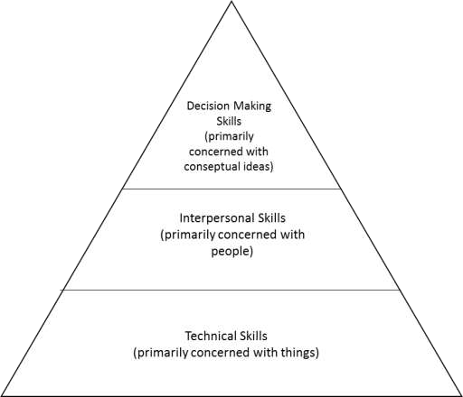

Figure 3. Managerial Leadership Skills

**Technical skills** involve the knowledge and the ability to use methods, processes, techniques, tools and equipment to perform a task. These skills are also sometimes called business skills. The technical skills are the easiest one’s to develop from the three management skills, but they can vary a lot depending on the job. (Lussier and Achua 2013, 9)

**Interpersonal skills** are also called people skills or soft skills. They are defined by Lussier and Achua as “the ability to understand, communicate and work well with individuals and groups through developing effective relationships.” We use our interpersonal skills when we interact with other people and because leadership is all about relationships we should focus on our interpersonal skills that realty is the base for good relationships. It is also important to see that interpersonal skills are based on many other skills like negotiating, motivating and conflict skills. (Lussier and Achua 2013, 10)

**Decision-making skills** deals with how we reason and make decision. “They are based on the ability to conceptualize situations and select alternatives to solve problems and take advantage of opportunities. It involves critical-thinking, analyzing alternatives and attempting to maximize positive outcome for the organization.” (Lussier and Achua 2013, 10) The decision-making skills are based on many other skills e.g. time management skills, diagnostic and the ability to be creative. (Lussier and Achua 2013, 10)

Because of the project managerial perspective, this thesis will focus mostly on the soft skills, meaning the interpersonal skills and decision-making skills, and furthermore, how leaders in projects deal with people and what kind of characteristics are needed for a successful and effective leadership.

# INTERNATIONAL PERSPECTIVE

This chapter will take a closer look to the international perspective to project management and leadership. In addition to define terms associated with international project management, the chapter introduces differences between national and international projects, the challenges that multicultural environment brings and what kind of competencies it demands from the project manager.

## International project

“An international or regional project is a project that involves multiple locations, entities, organizations and business units.” (Lientz and Rea 2003, 3) For example, international efforts by governments, efforts by firms to enter new markets and expand their customer base and international non-profit and aid agencies. International projects have become more and more frequent, because of globalization, mergers and acquisitions. International projects are complex and of that reason the traditional standard project management methods fail or work only partially. There are many differences between national and international projects associated for example with cost of the project, number of locations and risk etc. (Lientz and Rea 2003, 8-9)

## Multicultural team

Due to the competitive pressures and globalization of business are boundaries within and between companies, industries and countries breaking down. Organizations have established greater number of temporary and permanent international groups of people e.g. project teams and companies are increasingly promoting employees participating in multicultural teams. (Schneider and Barsoux 2003, 217) “People drawn from different functions, units and levels within and outside of the organization are having to learn to work together. - Corporations are also pooling their expertise across national boundaries.” (Schneider and Barsoux 2003, 217) Multicultural teams are not only possible in large companies but also can be found in small and medium-sized corporations. (Haghirian 2011, 123) Multicultural project teams bring together people with different perspectives, expertise and culture and because of that, people in a multicultural project team have different behaviour, value and beliefs. Multicultural differences can be national, functional and corporate. There are many strategic reasons for creating such teams: organizational integration, organizational learning, and managerial development. (Schneider and Barsoux 2003, 217)

There are many benefits for the company, management and employees to work in such multicultural teams. Managers and the organization can learn how to function effectively within different cultures. For the team members, they provide development opportunities to enhance their understanding of international issues and to appreciate better the interdependencies between units. (Schneider, Barsoux 2003, 217)

Many times, when a project team works together on an international basis, they rarely or never actually meet in person. That means that communication happens primarily using technical tools e.g. by e-mail or workgroup applications. Depending on the type of project, it is recommended to have a couple meetings in person e.g. project kick-off meeting. For example, in a standard project in a global company the level of virtual working can be higher than in a pioneer project where the working firms or colleges have never worked together. (Kuster, Huber, Lippmann et.al. 2011, 120)

## Leadership in different cultures

Haghirian (2011, 124) suggest that: “The leadership role in a multicultural team is an important aspect of cross-cultural management.” However, like the criteria of a successful project, also the expectation of what a good leader is, strongly differs across cultures.

“Leadership is strongly depending on cultural concept and there for not every leadership style can be implemented in all countries equally successfully. - Managers must be aware that their best practices of leadership in their home cultural context may not be successful at all in other places.” (Haghirian 2011, 123)

Leading a project abroad has been sad to be more challenging than a national project. Müller and Turner say in their book Project-oriented leadership that “Project managers working in their home country are on average more successful with their projects that those working abroad.” However, they also write that the rating of success is influenced by culture, because the decision on project success is influenced by the importance assigned to the different project success criteria. (Müller and Turner 2010, 58) This mean that the success of the project is depended of the perspective and the criteria’s set by the organization and the organizational culture.

## Project management in a multicultural environment

The project environment in international teams can be more difficult, because of the cultural and ethnical differences. Problems can come from different value sets, different perspectives, behavior, language etc. Although nowadays many project managers see cultural differences as a possibility and not as a problem. To work well in a multicultural project environment, a project manager should ideally have especially cultural awareness, language and communication skills, negotiating skills, conflict resolution skills and have a god attitude and conduct in multicultural situations. (Kuster, Huber, Lippmann et.al. 2011, 121)

Basic awareness of culture and cultural differences is necessary for the project manager and also for the team members in an international project. That is why it is important to prepare that one is aware of expected gestures, rituals and ceremonies. Not being prepared can lead to losing one’s credibility. Also, one of the most critical skills in multicultural environment is relevant language skills and understanding that people communicate and use body language differently. By language skills meaning correct vocabulary and expressions etc. that are appropriate for the target culture. (Kuster, Huber, Lippmann et.al. 2011, 121)

Negotiating skills and conflict resolution skills are important in every kind of project, but especially in a project in a multicultural environment. In a multicultural environment, one must take in to consideration that cultural differences affect how one should approach conflict situations and negotiations. That means the project manager must develop in addition to relevant cultural awareness, also excellent resolution skills. (Kuster, Huber, Lippmann et.al. 2011, 122)

Lientz and Rea (2003, 46-48) suggest in their book *International Project Management* that it is important to have two or more project leaders for any substantial international project. They also listed what general attributes are most important for an international project manager: problem-solving ability, ability to cope in multiple cultures, tenacity and the capability of pursuing issues, ability to communicate, a sense of humour, familiarity and knowledge of the business and prior experience in projects. As we can see, Lientz and Rea raised many of the same attributes as Kuster, Huber, Lippmann et.al.

A couple or little remarks that will help one to succeed as a project manager in a multicultural environment: reading about the culture and history if the country and learning about the political and economic issues, plunging in and working meaning leading by example, eating and drinking what the local people consume and making an effort when dealing with the managers. (Lientz and Rea 2003, 52-53)

According to the book *International project management* written by Kathrin Köster skills required by the project manager especially in international projects are (Köster 2010, 228):

* Global organizing skills meaning political awareness and strategic influence. The project manager need to be able to convince about the importance of the project.
* Technical skills meaning having the knowledge about the technology used or about to be developed by the project.
* Cross-cultural skills meaning knowledge about different national cultures and being able to adapt to different cultural scripts.
* Global communication literary meaning being able to speak several languages and to use contemporary communication technology.

The distributions of tasks and responsibilities can lead to conflicts, because of cross-cultural relations. In some work cultures, e.g. in Germany each employee is responsible mostly for specific activities and other areas of work should not be touched. In group oriented cultures decision-making and activities are not clearly defined or are more overlapping. These different attitudes and opinions about responsibility can lead to conflicts. (Haghirian 2011, 128)

“Group structure also influences how leader should behave.” (Haghirian 2011, 128) Hierarchies play an important role in many cultures, which means that age plays often a more important role then knowledge and achievements. On the contrary in Western cultures, positions are assigned according to performance. This means younger employees can be team leaders and be in more powerful positions. Also working styles are an issue that can lead to conflict. Some culture value holidays and family matters more than others. (Haghirian 2011, 128)

# THEORETICAL PART

This chapter introduces the Dulewicz’s and Higgs’s the integrated model of fifteen leadership competencies which has been selected to be the theoretical basis for the empirical part and there for also for the interviews. The purpose of this chapter is to give one better inside to the competencies and what they include.

## Fifteen leadership competencies

As the base of the interviews and the research this thesis will use in addition to the previous literature findings an integrated model of Vic Dulewicz and Malcolm Higgs (2003) that focuses on the leadership role of the project manager. They identified 15 competencies which influence leadership performance and they group the competencies into three types: intellectual (IQ), managerial (MQ) and emotional (EQ). There are five managerial, three intellectual and seven emotional competences. These fifteen competencies are used to explain the success and performance of the leader.

When unfolding the different competency factors, we will take also inconsideration other literature sources and at the end also add a list of other competencies and skills seen important for a project manager outside of the integrated model. The other literature sources are also for give a look for the international perspective of the competency of the project manager.

|  |  |  |  |
| --- | --- | --- | --- |
| Cluster | **Managerial (MQ)** | **Intellectual (IQ)** | **Emotional (EQ)** |
| Competencies | Managering resources | Critical analysis and judgement | Self-awareness |
|  | Engaging communication | Vision and imagination | Emotional resilience |
|  | Empowering | Strategic perspective | Intuitiveness |
|  | Developing |  | Sensitivity |
|  | Achieving |  | Influence  Motivation  Conscientiousness |

Figure 4. Fifteen Leadership Competencies according to Dulewicz and Higgs (2003)

### Managerial leadership

The management competence has in some literature sources been seen as a bedrock of leadership, but not necessarily the clincher for project success. It resembles the most traditional understanding of management; guiding and controlling people for the effective achievement of objective. The managerial competence address the basic leadership behavior and it consists of five dimensions: managing resources, engaging communication, empowering, developing and achieving. (Müller and Turner 2010, 21)

**Managing resources** is in addition to motivation one of the outstanding leadership characteristics. (Müller and Turner 2010, 22) Duelwicz and Higgs (2005, 111) described managing resources as planning ahead, establishing clear objectives, organizing all resources and coordinating them efficiently and effectively. Monitoring and evaluating staff’s work regularly and gives honest feedback.

These task looks are close to traditional management tasks and they should be performed to support efficiency in leadership. The extent of planning needed for a leader vary by leadership style; if one is more a people-oriented leader (for example in research departments) or a task-oriented leader (for example in repetitive maintenance projects). In addition, there are high-risk projects and environments where planning is fatally important (for example building a power station). (Müller and Turner 2010, 23)

Also, organizing resources, establishing their goals, developing action plans, performance monitoring, evaluation and giving feedback are linked with the leadership style chosen. The challenge of the leader is to assess the situation and the circumstances correctly when choosing the way of managing resources. This means this is not a personal choice, but it must fit to a project’s situation. (Müller and Turner 2010, 23)

In the research of Müller and Turner (2006) is shown that **engaging communication** is found to be increasingly important to project success and for successful project managers the communication capabilities have been a kay factor. That is why project manager should be a good communicator. It is critical for keeping the project moving, identifying and solving problems etc. (Gido and Clements 1999, 91)

Engaging communication has three different dimensions (Müller and Turner 2011, 24):

1. Availability for communication, which means the physical and mental preparedness for communication with others.
2. Setting the stage for mutual exchange means to encouraging exchange by listening and evaluating information from different perspectives and then combining it with their own opinion and discussing these with joint objective. It is important to take in to consideration, that this includes in addition to verbal communication also body language.
3. Finding the right level of communication detail, meaning “finding the right amount and type of information to communicate to for a given audience.

Meaning adjusting the information to the level of understanding of the receiver.

**Empowering** is defined by Dulewicz and Higgs as giving staff autonomy and encouraging them to take personally challenging and demanding tasks. Encouraging a critical faculty and a broader perspective. Individuals want to show that they can accomplish goals and meet challenges and that is why it is important to create a work environment and culture that empowers people, so that the project manager involves team members in decisions and empowers them to make decisions within their area of responsibility. (Gido and Clements 1999, 86)

Empowering teams contributes strongly to work-related results. However, this does not mean that a high level of empowerment would automatically lead to project success. In some projects, giving to much freedom to team members can lead up to missing the project goal. (Müller and Turner 2010, 26)

This factor is important because the team members are often skeptical about the manager’s commitment to the new work order in the beginning and during the implementation of empowerment, the team members watch the management closely and are sensitive to management’s actions. In implementation, one should take in special attention (Müller and Turner 2010, 26):

* Sharing information with everyone, but taking in to account to avoid information overload.
* Collaborative development of structures of autonomy.
* Replacing hierarchy with empowered teams.

Empowering is especially important to virtual teams. The lake of face-to-face meetings can result to correlation between empowerment and work result.

**Developing** as a competency has many different perspectives of leadership. One description is that developing is the bolstering of others’ abilities through feedback and guidance. Dulewicz and Higgs (2005, 111) describe it as believing in others potential and encouraging them to take even more-demanding tasks and roles. Investing time and effort in coaching team members and believing that critical feedback and challenging are important.

An effective project manager is committed to the development and training of the members of the project team and for that sees the project as an opportunity to add value to team members experience. (Gido and Clements 1999, 89) Developing is highly linked to motivation, because one way to achieve motivation is by challenging team members and giving them a change to develop themselves by growing their skills and authority etc. It has been shown that this impacts job satisfaction and commitment of the employees and in addition relate positively to project success. (Müller and Turner 2010, 27)

Developing at the project level is usually seen as targeted feedback, providing mentoring, offering challenging assignments and acknowledging strengths and contributions of team members. Because of the fixed duration of projects there is often little room and time for employee development with in projects. In these situations, it is suggested that the project manager collaborates with line managers and HR department to develop a suitable strategy for the development of employees. (Müller and Turner 2010, 27-28)

**Achieving** is defined by Dulewicz and Higgs (2005, 111) as willingness to make decisions involving significant risk to gain an advantage. Selecting and exploiting activities that result in the greatest benefit to the organization. In other words, it is about optimistically striving for continuous improvement of performance. Project manager with this kind of competency takes more calculated risks and is more supportive for innovations. This kind of project managers are often also more proactive and persistent, because they have more optimism and don’t get defided by setbacks. (Müller and Turner 2010, 2829)

### Intellectual leadership

**Critical analysis and judgement** helps the leader in the day-to-day assessment and evaluation of different types of information, meaning comprising analytical skills. In other words, taking into account internal and external factors and information and coming up with the best possible solution for the given circumstances. (Müller and Turner 2010, 31) This competence has been seen in many literature sources to be one of the most common factors among successful leaders. Although Müller and Turner did not see in their research a direct connection with this particular competence and success in most project types.

**Vision and imagination** relates to the principle to being creative and setting a vision for the project team to follow. In other words, being creative in how to achieve the project objectives. There are different opinions about the fact if the vison should be set by the project manager or the project sponsor. Müller and Turner say that because the project sponsors set the objective for the project, therefor they should also define the vision for the project outcome. Müller and Turner also state that too much imagination from the project manager can lead up to frequent changes to the scope of the project and that can default the project success.

“**Strategic perspective** addresses the project manager’s ability to see the bigger picture and evaluate the impact of change, risks and stakeholders on decisions and tasks in projects.” (Müller and Turner 2010, 32) This dimension is more sensitive to project type that any other. For example, in IT-projects it is seen as a good thing if the project manager can see the bigger picture and is sensitive to the stakeholders needs. However, in “general” projects a too broad of a picture and overly strategizing can hinder the project and there for it could be better that the project sponsors adopts this perspective. (Müller and Turner 2010, 33)

### Emotional leadership

This field of competences addresses the interpersonal and social dimension of leadership. Müllers and Turners research showed that this cluster of competences influence the project success the most across all types of projects. This competency field means the interpersonal skills also called soft skills.

**Self-Awareness** is defined by Dulewicz and Higgs as awareness of one’s own feelings and capabilities and to manage these in a way that one fells in control. It’s also one’s capability to manage one’s emotions and to control their impact in a work environment. It is the keystone of emotional intelligence. By being aware of one’s own feelings, the leader can more easily recognize how others feel and act more empathetically. This builds trust and reciprocity among people. (Müller and Turner 2010, 36)

**Emotional resilience** is needed for dealing with conflicts, timelines and pressure. It enables high performance through controlling emotions under pressure. It is balancing needs of the situation with the concerns of the individual. A person with high emotional resilience can cope with stressful situations, with the support of the resources and the team. A person lacking in this field could be resistant to change and hinder new and innovative ideas. (Müller and Turner 2010, 36-37)

As we have seen before projects can be highly stressful and they require to be flexible in changing situations and to recover from setbacks and the project manager will face a lot of uncertain situations. Also, there comes a lot pressure from the stakeholders and project sponsors. That is why the project manager needs to have a good personal stability. (Köster 2010, 232)

“**Intuitiveness** links rational thinking with gut feeling” (Müller and Turner 2010, 38) With the rational data the project manager can make decisions with his or hers gut feeling which is referred to feelings that accumulate of life-long experience. This is important for example in situations where the decision-making time is very short or there is little reliable information for the decision making. (Müller and Turner 2010, 38)

**Interpersonal sensitivity** is closely linked with empathy. Defined by Dulewicz and Higgs (2005, 112) as taking in to account and being aware of the needs and perceptions of others. Through this awareness building the commitment and trust of others. An empathic or an interpersonal sensitive person can read from verbal and non-verbal signs and this is very important in environments where there is a high level of interaction with people.

Related behavior includes listening and taking into account other people’s opinions, recognizing the needs of others, appreciating effective relationship with others and encouraging an ambiance of co-operation. The lack of interpersonal sensitivity can lead to hurtful interactions and confrontation. (Müller and Turner 2010, 39)

“**Influence** is about shaping the outcome of interactions” (Goleman 2002, 265(müller ja turner)) When influencing followers, the leaders uses self-awareness to control their own emotions and interpersonal sensitivity to read other people’s emotions. Dulewicz and Higgs (2005, 112) defined influence as pursuit to change others view based on an understanding of their position. in other words, influence is done by being able to persuade and manage the emotions of others. This happens by reading the emotions of others and responding to them to move an interaction towards to the wanted outcome. (Müller and Turner 2010,40)

Project managers use influence when they make team members and stakeholders listen, conveys their own position on an issue and then appeal to the reasoning of a given solution. This is important especially in projects that are highly complex and/or executed solely. For example, organizational change projects. (Müller and Turner 2010, 41)

One of the classic themes in management is **motivation**. It is included for example in the hierarchy of needs by Abraham Maslow (1943) and in the theories on motivational and hygiene factors by Frederick Herzberg (1987). A short definition by Dulewicz and Higgs

(2005, 112): “Motivation is drive and energy to achieve clear results and impact.” Motivation should be looked from two sides. Motivation on a person’s own performance and the effect on other people’s motivation and their performance. (Müller and Turner 2010, 41) A competent project manager understands what motivates team members and creates a supportive environment and also is highly motivated themselves and by that sets a positive example for the team. (Gido and Clements 1999, 86,89) The lack of motivation can impact not only the performance of the individual, but it can also influence the team’s overall performance negatively. (Müller and Turner 2010, 41)

In the research of Müller and Turner is shown that motivational capabilities of the project manager correlate positively with the project success in all types of projects. It is especially needed in projects of medium complexity. (Müller and Turner 2010, 42)

**Conscientiousness** is also found in many of the well-known theories directly or in combination with other traits. It is sometimes referred to as “attention to detail”. (Müller and Turner 2010, 43) It is defined by Dulewicz and Higgs (2005) by “displaying clear commitment to a course of action and showing personal commitment to pursuing an ethical solution to a difficult business issue or problem.”

Conscientious people are often seen as organizational role models. They are typically reliable, trustworthy and are consistent with their words and actions. They are the people how keep things running and in outstanding performances can be traced back to conscientiousness. In project management, this factor is needed for example paying attention to details, being committed to delivering the project outcome, establishing team morale and showing ethical behavior. That’s why it is a key competence for project management according to Müller and Turner. (Müller and Turner 2010, 43)

Dulewicz and Higgs also that although a person’s emotional intelligence is a measure of their personality, the success of a leader is not dependent on their personality but on the leadership style adopted. We are born with a certain personality, but we can also vary our leadership style with different emotional competencies depending on the project. We are able to develop these emotional competencies and through that also different leadership styles. (Müller and Turner 2010, 19-20) It is suggested that a team leader should aim to balance personality types across the team. (Müller and Turner 2010, 19)

Later, in the conclusions this fifteen leadership competency model and other literature findings will be compared to the results of the interviews and the profile of a competent project manager will be assembled.

# EMPIRICAL PART

In this chapter, the interviews will be unwrapped and analysed. Every interview is one by one analyzed. The interview consisted from open questions dealing with project management, leadership skills and competences in international projects and challenges in international project management.

Every interviewee filled out an excel-sheet with the fifteen leadership competencies evaluating their importance by giving points from 0 to 3. 0= not important, 1= not that important, 2= quite important and 3= very important. Every interviewee can give a maximum of 30 points, to avoid that the interviewee gives three points to every competency.

## Interview No. 1: Rana Dababneh

Rana Dababneh (M.Sc. in engineering, University of Jordan) biggest and most important project that he was leading was a Orange Jordan network project in Amman where she led two stages of the project: the project founding phase and the first expansion phase. The project was about building GSM network from scratch and the project was highly multicultural. The project was lead in Jordan and the project team was responsible for the organizational headcounter in France. Also, the project team consisted of several different nationalities. In later phases in her carrier she has lead small and big project regarding to his job description inside the organization e.g. change and development projects.

Orange network project was in Jordan opinion her most successful project. As success factors, she mentioned that they had the right kind of combo in the project team. They had competent professionals in every part on of the project. Also, the methods and guidelines used where clear and consistent. Although the project was done in a completely new environment, methods where controlled and resolved without major changes. A big thing was the good communication and relationship with the client and the success of this client collaboration was very important for the success of the project.

### Challenges in international projects

Rana brought up as challenges in international projects differences in language, culture, mode of operation, legislation and also the multi-ethnicity meaning different backgrounds and expectations inside the project team. Also, if the project is spread out to different locations, there can be challenges with the time difference. A big time difference can over time become to a burden for the people involved in operations which demand working with the time difference.

Rana has seen multicultural differences in the project team mostly as a positive thing if one is aware, recognize and is prepared to the differences. In her opinion people around the world are surprisingly similar. Having clear goals and inner motivation is very important when overcoming challenges in international projects. When the team will come together to work on a goal, the differences inside the team will not arise problems.

If there are many people from one language group, the working language can easily change e.g. from English to German. In worst case this can lead up to cliques. To prevent clique from emerging inside the project team can be prevented in Rana opinion by creating an organizational culture which is permissive and the goal which towards the team is working on is made clear.

### The importance of the project manager for the success of the project

The project manager and his or her skills are extremely important to the success of the project in Rana opinion. She underlined that any business success is linked to people. The most important thing is that people are motivated and tuned in to work for the project. Rana names two levels which impact the success of the project in his opinion:

1. The role of the leaders is very critical in project like work. If the leadership is not done right and the project manager is clueless, is the project domed.
2. Although the project manager would do his or her job well, but the project team is not in the right place or the people in the team are not suitable for the project is the project on the road of failing.

This all means that the project managers skills do not ensure results, but with the right kind of project manager and team, success is possible. In other words, the leadership provided by the project manager is central, but it needs to be complemented with a team that is composed correctly.

### Analysis of the competency figure

The most important clusters according to Rana is firstly the managerial cluster and secondly the emotional cluster. From the figure, one can see that in Ranas opinion managing resources, engaging communication and motivation are the most important competencies. Like before mentioned in Ranas opinion defining and clarifying the goals is the most important. It’s the core of leadership. Also, a project manager must be a good communicator. He or she must know how communicate to the project team what they are pursuing and why. Through that generate inner motivation, (because the project is not supposed to do for the project manager, but for the sake of the goal.) She scored the managerial competency cluster 12 from the possible 15. That is a very high result.

Rana sees also the emotional cluster to be very important for the success of a project. The fact that a project ether is successful or not depends very much on the people involved in the project. That’s why knowing how to read people’s needs is important.

He gave the emotional competency cluster 13 poits from the possible 21.

The intellectual competency cluster is in Rana opinion of course important, but the lack of intellectual leadership from the project manager can be replaced by hiring a person with these kinds of competences to the project management team. This is also seen in the graph. He scored this cluster as 5/9. Critical analysis and judgement and strategic perspective are determined by Rana as only quite important and vision and imagination as not that important.

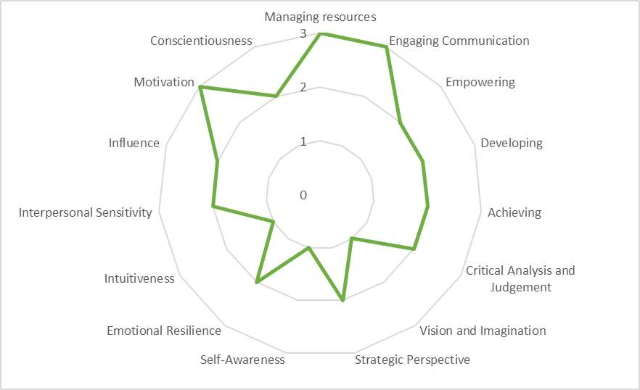

Figure 5. Competency Importance Evaluation according to Rana Dababneh

### Important competencies

Rana wanted to bring up the importance of “court vision”. Meaning the project managers ability to actively understand what is happening and being two steps ahead of the risks. This is crucially important, because reactive management just does not work in a long run.

Also, being systematic is one competency that Rana raised on top of the list. A project manager should be systematic in all matters regarding the project. One cannot be too generous. There is no matter to big or to small, so that it would not affect the project manager. Project managers must take themselves out of their comfort zone, no matter if he or she likes the task. A project manager must also possess a level of maturity and responsibility and there of understand that he or she is most times the last one leaving the office. This relates to the fact that the project manager is in the end the one how carries the responsibility that things processed as planned.

Rana also wanted to point out, that project management is surprisingly challenging. Nobody can be too good at it and unfortunately often in business life project management is not appreciated enough. A large number of executives think that almost any one has natural project management abilities and appoint line managers as project leaders. This is many times the reason why a project tumble. Truly competent project managers with good leadership skills are surprisingly thin on the ground.

## Interview No. 2: Omar Shoshan

Omar Shoshan (M.Sc. in Digital Media and Journalism) is currently working as the director of the regional government reform at the Regional council and Vice President at ‎[Watershed & Development Initiative - WADI مبادرة مساقط المياه - وادي](https://www.facebook.com/WADIJORDANDEV/?eid=ARCodVDFBcf_5MIPDRwjbApnY__1tN7BtWkgBUpE4e9mvdu8MvAhPIq6e4FpJCZT_PQXgFMyseVbyXCm&timeline_context_item_type=intro_card_work&timeline_context_item_source=1208082668&fref=tag)‎ professional background is in regional planning and public administration. The experience in managing regional development and administration projects can be seen in his answers.

Shoshan has experience of being a project manager in two international projects. In years 1998-2000 he was the project manager responsible for the evaluation, monitoring and supervising of the substance and administration of all 10 international projects financed by the USAID.

### Challenges in international projects

Shoshan brought up very similar aspects than Rana, when it comes to the differences between international and national projects and their challenges. Combining different working cultures and knowing how to communicate in multicultural environment are challenges that a project manager must overcome when dealing with cultural differences in international projects. Also, Shoshan mentions differences in legislation and administration as a challenge in working internationally. Communication language in the international projects that Shoshan has participated has been English which has been a foreign language for all the partners.

### The importance of the project manager for the success of the project

In Shoshan opinion the project manager and his or her leadership skills are most essential for the project success, because working in international projects is often leading networks. Owner organization of the project does not have direct authority power to the participating organizations. This means that project manager’s skills on project substance and strategic thinking but especially on networking and communication are critical for the project success.

### Analysis of the competency figure

Shoshan said that it was surprisingly hard to fill out the excel sheet, because all the competencies in the Dulewicz’s and Higgs’s competency model are useful and an ideal project manager would have all these capacities in high level. From the clusters Shoshan highlighted the emotional cluster to be most important one and also managerial competency cluster is in his opinion more important than the intellectual one.

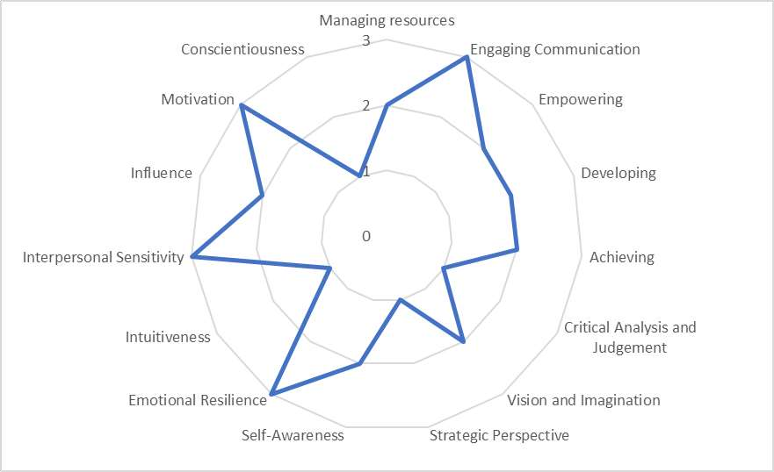

Figure 6. Competency Importance Evaluation according to Omar Shoshan

In his opinion, a project manager should have a clear view about the goal and objective and many of the intellectual shortcomings can be recovered by the competent project staff. Like seen in the graph, Shoshan gave lower marks to the intellectual competencies: only three form potential nine points. He emphasized that that it’s not because he would not respect them and wouldn’t find them important for a project manager, but especially in the framework of international project they are not as critical for the success of the project

He raised the issue that it is important to have managerial skills, but even more the emotional competences in order to create the spirit and motivate project partners and staff from different countries. Shoshan highlighted three of the seven competencies in the emotional competency cluster: emotional resilience, interpersonal sensitivity and motivation. Communication was also scored high. The overall score in the emotional competency cluster was 15 from the possible 21 and in the managerial competency was scored 11 from the possible 15.

The importance of communication and motivation as a success factor of a project came up when Shoshan talked about one of his golden moments of his project management career: “I’m now working as Vice President at ‎[Watershed & Development Initiative - WADI مبادرة مساقط المياه - وادي](https://www.facebook.com/WADIJORDANDEV/?eid=ARCodVDFBcf_5MIPDRwjbApnY__1tN7BtWkgBUpE4e9mvdu8MvAhPIq6e4FpJCZT_PQXgFMyseVbyXCm&timeline_context_item_type=intro_card_work&timeline_context_item_source=1208082668&fref=tag)‎. In the beginning of this year we established four thematic working groups for the reform: regional development, land use planning and environment, rescue services and agriculture. In the beginning, I gave relatively detailed guidelines and time schedules to the working groups. During the last months, I’ve been really busy with the administrative and organizational matters of the new region. So, the working groups had to work more on their own. I was probably a bit worried, how the working groups will manage without my direct guidance. Two days ago, we had our monthly meeting with the agriculture working group. Progress of the work had been just excellent, better than anyone could expect. In the end of the day, I obviously had been able to give clear objectives (=communication) and passion to the work (=motivation). And of course, members of the working group are really competent. “

This example is from national project, but one can find analogue with international projects as well e.g. members of the working groups come from different organizations and Shoshan doesn’t have direct authority to any them. This kind of examples give a good view of the practical implementation of the project managers competences and what it takes to make a successful project.

# CONCLUSIONS

In this chapter, the results of the interviews will be analyzed and conclusions will be made by comparing the literature sources and the interviews. At first the comparison will be made between the competency clusters and then between some of most important individual competencies. Also, the interviewee’s opinions to the international perspective are summed up and compered to the literature sources. In the end, there is a conclusion on a project manager’s competency profile, based on the competencies that are mostly highlighted.

## The clusters

The answers of Rana and Shoshan for the question, what is the most important competency cluster, were surprisingly similar. Both emphasized the importance of managerial and emotional clusters and questioned the importance of the intellectual cluster.

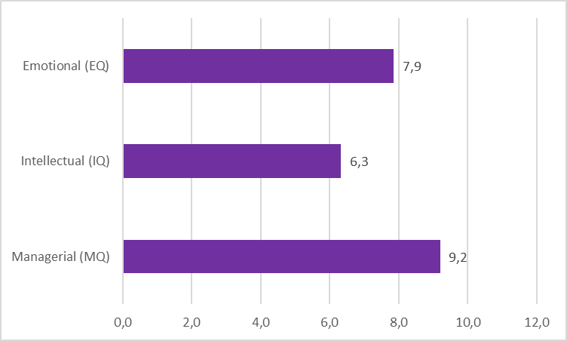

Figure 9. The average point of the competencies in the clusters

The figure shows that the competencies in the managerial cluster got the best average points 9,2 from the maximum 12 points. The interviewees had the same opinion than the literature, that the managerial cluster and many of the competencies in the cluster like managing resources, empowering and engaging communication are basics of project management. These competencies are necessary for running and leading the project and there for important for the success of the project.

The competencies of the emotional cluster were second with the average points of 7,9. This cluster also had many competencies, that the interviewees recognized to be important, but also some, that they felt not that important. One can see from the figure 10, that conscientiousness, influence and intuitiveness did not get from any of the interviewees 3 points. Intuitiveness even got only 1 point from all of the interviewees.

The competencies in the intellectual cluster were found the least important according to the interviewees with average points of 6,3. The low ranking of the intellectual cluster can be explained by the fact that none of the competencies in the cluster got from the interviews the maximum 3 points. The competencies were graded only as “quite important” or “not that important”. Like the interviewees, also Müller and Turner (2011) were in the opinion that the intellectual part is not that important for the success of the project. Rana and Shoshan suggested that the shortcomings in the intellectual part of the competencies can be replaced with competent group members that have high intellectual skills.

Good project leaders do not always have to be experts in the field, where the project is carried out. On the other hand, the best expect on the specific subject are not always the best leaders. Many times organizations hire the most accomplished expert on the subject as a project manager or a superior. This is not necessarily a bad thing, but in the worst-case scenario the expert is not competent to lead a team of people. As an outcome, the project is not lead properly and is destined to fail. Also, by nominating the best expert as the project manager, important expertise might be lost, because the expert must concentrate his or her energy on managing people. Therefore the intellectual part of managing can be externalized to other team members in the project team, but the emotional and managerial part are vital for the project manager to possess.

The average points of the clusters where still relatively evenly spread, meaning that every cluster has important and not that important competencies. That’s why it is important not only to stare at the cluster, but also go through the different competencies and their importance.

## The competencies

The figure 10 shows that there were not big differences on the importance in the competencies between interviewees. Within every competency the difference was maximum 1 point. This shows that the professionals where surprisingly of one mind.

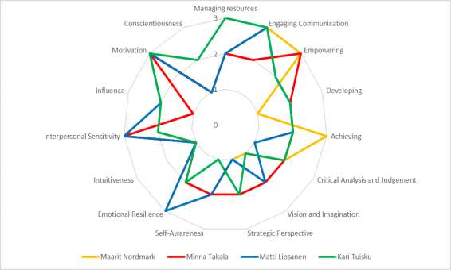

Figure 10. Summary of the Competency Importance Evaluation of the interviewees

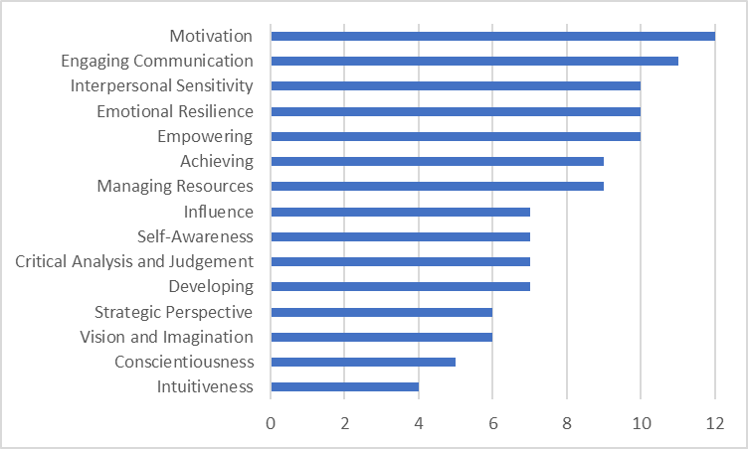

Figure 11. The total points for the competencies

To observe the ranking of the competencies the figure 11. shows the total points of every competency. The maximum score was 12 points. None of the competencies got zero points, but the lowest score got intuitiveness with 4 points. The competencies that got most of points and which are analyzed after the figure 11. were motivation with 12 points, engaging communication with 11 points, interpersonal sensitivity, emotional resilience and empowering with 10 points.

### Motivation

Motivation was the only competency that every one of the interviewees endorsed as highly important for the project manager and the success of the project. In their opinion it does not matter if the project is carried out in national or multicultural environment. Motivation is important in every kind of project and it is one of the key factors of project success. The project manager must have a high level of internal motivation, and he or she must know how to motivate the project team i.e. how to light a fire and passion inside every worker participating in the project. Also empowering, which is close to motivation, was rated high; 10 points from the possible 12.

### Engaging communication

Communication, and especially clear and the right kind of communication is very much linked to motivation, empowering and influence according to the interviewees. It was ranged as a very important skill for the project manager and it got 11 points from the maximum 12. Good communication is the main tool to reach and influence internal motivation among the project team which can also be called empowering. This all will result as effectiveness and project success. Especially Rana and Shoshan pointed out that project manager’s capability to define and clarify goals by good communication, is necessary for the success of the project.

### Interpersonal skills

Different interpersonal skills like emotional resilience and self-awareness are also critical part of the success of the project manager. The literature and the interviewees reminded every now and then, that in project management the object of the leadership and the most important resource to manage are the people in the project team. That is why emotional and interpersonal skills are important. Also, the possible challenges of the international projects are better manageable with high level of interpersonal skills.

## The international perspective

The interviewees did not see that national and international projects differ that much, as the literature says they would. The literature sees that international projects and working in a multicultural environment is very demanding and challenging. The literature also lists multiple differences and challenges between national and international projects that the project manager must take in to consideration in order to succeed.

The interviewees agreed that the differences, that do come up when operating in a multicultural environment, are culture related, either because of the culture of the country, or the different working culture. But the interviewees also pointed out that many of the possible challenges in international projects are very similar to the challenges that they face in national project as well.

## The competency profile of a competent project manager

Competency model are important and a perfect project manager would possess all of the competencies and even more. But in real life that’s not possible. Therefore it is necessary for the competency profile to identify the most important ones. This thesis supports the point of view that in order to be a successful project manager, one has to be especially competent at communication and managing resources and being able to empower and motivate people. High level of interpersonal sensitivity and emotional resilience is also recommended.

Motivation is the number one on the competency profile, without a doubt. It has been highlighted by the interviewees and the literature sources multiple times and it seems to be a key element of a good leadership and effective project management in every situation.

Although managing resources was not the most important competency according to the interviewees, they mentioned that it is a fundamental competency that makes the base of management. Also, according to the literature, it is in addition to motivation one of the outstanding leadership characteristics, that is vital for the good leadership and management. Engaging communication is critical not only in project management, but in every kind of leadership and management. Like mentioned before, communication is a key element for project success. Good communication can not only solve problem situations and conflicts, but it can also prevent them.

Like mentioned before, interpersonal sensitivity is linked to empathy. Empathy helps to understand others perspective and being aware of others need. It helps especially in new and challenging situations, like working in a multicultural environment, with people from different backgrounds and values. Being able to understand others can help to avoid conflict situations. Emotional resilience is needed for the stress that the challenges in projects bring e.g. tight deadlines, conflicts and pressure. It helps to overcome disappointments and to continue despite of the problems possibly emerging.

# RECOMMENDATIONS

The outcome and the overall results achieved of this thesis were successful, but there are also recommendations for future research which are raised from this study.

The international perspective could go deeper into the subject in the future and it could have been highlighted more. Cultural differences and their influence on project management and the skills of the project manager could be a worth of closer study. The fact that the interviewees where Finnish can also have influenced the answers touching the international perspective. Project managers in Germany or India could have different views on the challenges in multicultural environment and also have different perspectives about project management in general.

The model chosen to the theoretical part was valid and it supported the purpose of the research. However, it would be interesting to study also different competency models and theories with the same research methods. Also, the tool used to measure the importance of the competencies could be different and through that give different results. It would also be interesting in the future to try to find similar studies can compere then together.

In this thesis, there has been applied one tool of qualitative research method, namely the interviews. Some other methods of research could also be applied to get more inside and qualitative data. The take of the empirical part was successful. All the professionals had experience in managing different kind of projects in different kind of environments, although their educational backgrounds were similar. The differences in their professional background influenced their answers and gave a variety of perspective and opinions. The take could have been larger, which could have again given more valuable inside of the subject and maybe given also even more clear results to the final competency profile. A bigger take would have also increased the liability of the survey.

The knowledge that the professionals have provided, has influenced the result significantly. The fact that the interview results and the information from the literature sources supported each other increases the liability of this research and its result.

These mentioned current study limitations can be overcome in the future research and there for provide potential subjects for bachelor thesis’s.

# APPENDIXES

## The Interview form

Interview: The leadership competencies of the project manager

Tell a little bit about your professional background:

* What are the main points of your professional carrier?
* What is your experience in project management?

What are the biggest challenges in international projects in your opinion?

How do international projects differ from national projects in your opinion? Or what are the biggest differences?

How important is the project manager and his or her skills in the success of the project?

What is personally the most successful project you have lead or participated? Why?

After filling out the excel sheet:

What is in your opinion the most important competency clusters (managerial, intellectual and emotional) and why?

Justify your choices in the excel file. Why is some competency more important than the other in your opinion?

What other competencies would you suggest that are important for a project manager in an international project?

What else would you like to say on the subject?

# LIST OF FIGURES

Figure 1. Thesis structure. Source: Author’s own creation

Figure 2. Emotional and Social Intelligence Competencies according to Goleman et. al. Source: Author’s own creation

Figure 3. Managerial Leadership Skills. Source: Author’s own creation

Figure 4. Fifteen Leadership Competencies according to Dulewicz and Higgs (2003) Source: Author’s own creation

Figure 5. Competency Importance Evaluation according to Kari Tuisku

Figure 6. Competency Importance Evaluation according to Matti Lipsanen

Figure 7. Competency Importance Evaluation according to Minna Takala

Figure 8. Competency Importance Evaluation according to Maarit Mordmark

Figure 9. The average point of the competencies in the clusters. Source: Author’s own creation

Figure 10. Summary of the Competency Importance Evaluation of the interviewees. Source: Author’s own creation

Figure 11. The total points for the competencies. Source: Author’s own creation

# LIST OF REFERENCES

Bell, M. 2013. Effective and Efficient Project Manager – A simple approach to structuring, running and making project successful. Simple Improvement Ltd. Available at:

[http://www.simpleimprovement.co.uk/Effective%20and%20Efficient%20Project%20M anagement.pdf.](http://www.simpleimprovement.co.uk/Effective%20and%20Efficient%20Project%20Management.pdf) Accessed on May 10, 2017.

Dulewicz, V. & Higgs, M. 2003. Leadership at the top: The need for emotional intelligence in organizations. International Journal of Organizational Analysis

Gido, J. & Clements, J. 1999. Successful Project Management. South-Western Collage Publishing

Goleman, D., Boyatzis, R. & McKee, A. 2002. Primal Leadership: Learning to Lead with Emotional Intteligence. Harvard Business School Press

Haghirian, P. 2011. Successful Cross-Cultural Management: A guide for international management. Business Expert Press, LLC

Khan, S., Long, C. & Iqbal, J. 2014. Leadership Competency: A Tool for Project Success. Middle-East Journal of Scientific Research, IDOSI Publications. Available at: [https://www.idosi.org/mejsr/mejsr19(10)14/2.pdf.](https://www.idosi.org/mejsr/mejsr19(10)14/2.pdf) Accessed on May 21, 2017.

Kuster, J., Huber, E., Lippmann, R., Schmid, A., Schneider, E., Witschi, U. & Wüst, R. 2011.

Project Management Handbook. Springer

Köster, K. 2010. International Project Management. SAGA Publications Inc.

Lientz, B. & Rea, K. 2003. International Project Management. Academic Press

Lipsanen, Matti. Director of the regional government reform at the Regional council of Häme, Interview June 1, 2017

Lussier, R. & Achua, C. 2013. Leadership: theory, application & skill development. Cengage Learning

Müller, R. & Turner, R. 2010. Project-Oriented Leadership. Gower Publishing Limited

Nordmark, Maarit. Managing Director at Vincero AB, Interview June 9, 2017

Pinto, J. & Slevin, D. 1987. Critical Success Factors in Effective Project Implementation. IEEE Transactions on engineering management, voll em-34 no. 1. February 1987

Schneider, S. & Barsoux, J. 2003. Managing Across Cultures. Person Education Limited

Takala, Minna. Senior advisor at the Regional Council of Häme, Interview June 6, 2017 Tuisku, Kari. CEO at DB Pro Oy, Interview May 26, 2017